Sklearn Gradient-Descent Linear Regression (House Prices)
Extended Optional Lab – C1_W2_Lab05 | Multi-feature prediction with StandardScaler + SGDRegressor
Problem Statement
Given 100 houses described by size (sqft), number of bedrooms, number of floors and age, predict selling price (in $1000s). The classic closed-form normal equation works, but the learning objective is to master an iterative, scalable solver—stochastic gradient descent—inside scikit-learn, together with the mandatory z-score normalization that makes SGD converge reliably. The extended lab also asks how sensitive the solution is to noise, sample size and hyper-parameters, and how to communicate results to different audiences.
Solution Strategy
1) Load houses.txt → X (n×4), y (n). 2) Fit StandardScaler on training features and transform. 3) Instantiate SGDRegressor(max_iter=1000) and call fit on the normalized matrix. 4) Extract coef_ / intercept_ (normalized scale), predict, compute R² / RMSE. 5) Visualize target-vs-prediction per feature. 6) Provide three alternates (OLS LinearRegression, pure-NumPy batch GD, Pipeline). 7) Monte-Carlo simulation over noise σ and sample size n. 8) Explicit “what the model can / cannot predict” and audience-adaptation notes.
Solution (Key Results)
Normalized coefficients ≈ [109.85, –21.08, –32.26, –37.93], intercept ≈ 362.2 (very close to the pure-Python GD lab). Training R² ≈ 0.959, RMSE ≈ $21k. Size is the dominant positive driver; age and floors are strong negative drivers after scaling. A production Pipeline(StandardScaler, SGDRegressor) yields identical scores while eliminating the risk of forgetting to scale at inference time.
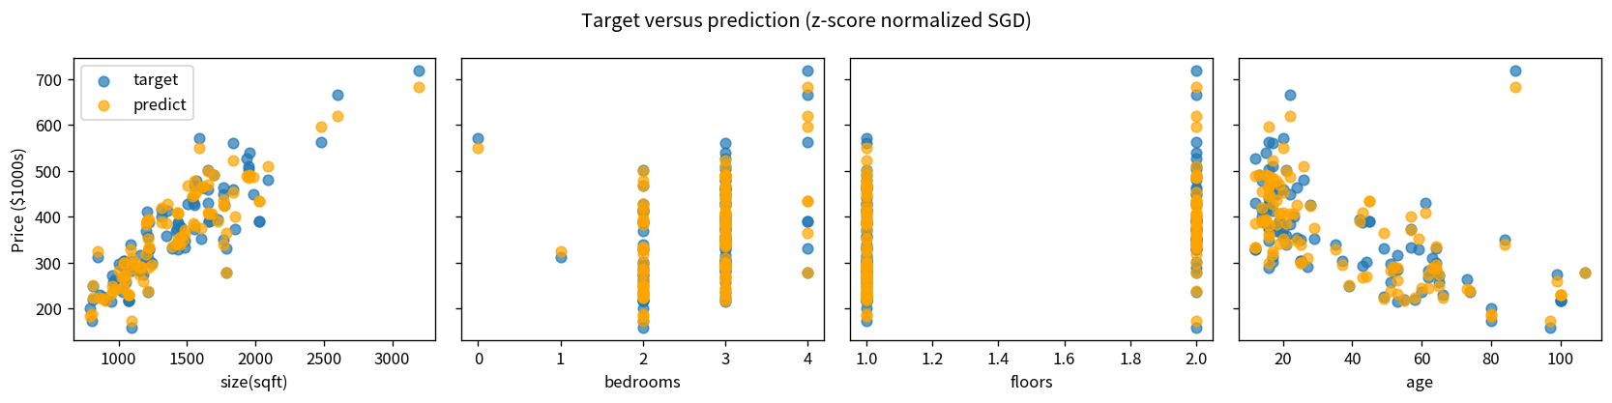
Figure: Target (blue) vs SGD prediction (orange) for each original feature. Strong linear association is visible for size and age.
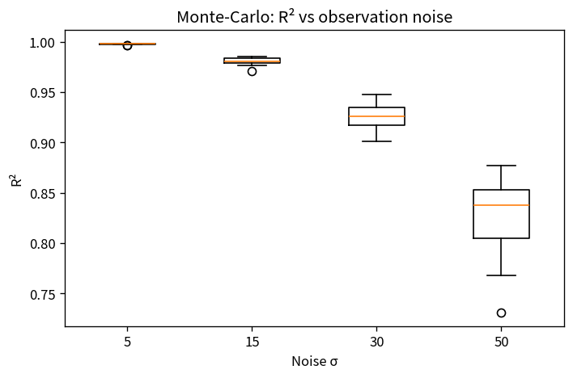
Monte-Carlo: mean R² falls and variance rises as observation noise σ increases—expected behaviour of any linear model.
Key Takeaways
• Feature scaling is not optional for SGD; peak-to-peak ranges must be comparable.
• Sklearn’s SGDRegressor recovers essentially the same parameters as hand-coded batch GD while scaling to larger data.
• Always wrap scaler + model in a Pipeline for production; otherwise inference will silently use the wrong scale.
• The model captures linear relationships inside the training support; it does not extrapolate safely, does not imply causality, and supplies no automatic uncertainty intervals.
• Report residual diagnostics and the training-data envelope; adapt vocabulary to data-literate vs executive vs non-specialist audiences.
Files: Practice_Skeleton.ipynb | Solution.ipynb | Reusable_Template.ipynb | Cheatsheet | Responsible-Use & Top-10 Applications document.

